УДК 004.8:811.581

**Bakhitbekov A. Zh. 1, Sagynbay A.E. 2, Bakhitbekov A. Zh. 3**

1International University of Information Technology, Almaty, Kazakhstan

2Nazarbayev University, Astana, Kazakhstan

3Nazarbayev Intellectual School, Almaty, Kazakhstan

Scientific supervisor: Bakirova G.S.

**DEVELOPMENT OF AN INTELLIGENT WEB PLATFORM FOR LEARNING BUSINESS CHINESE BASED ON ARTIFICIAL INTELLIGENCE TECHNOLOGIES WITH AI INTEGRATION CHATBOT AND MULTIMEDIA VIDEO CONTENT**

**Abstract.** The article presents a concept for developing a web platform for learning business Chinese using artificial intelligence technologies and interactive video content. It considers the prerequisites for creating a digital educational solution focused on developing practical business communication skills in an international trade environment in relations with China. The architecture of the platform, including the client and server parts, as well as the natural language processing module, is described in detail. The principles of user interface design aimed at ensuring convenience and intuitive interaction are highlighted. The results of testing functional and non-functional requirements are presented. Attention is paid to the integration of an AI chatbot as a tool for modeling real negotiation scenarios and automated feedback.

**Keywords:** web platform, artificial intelligence, AI chatbot, business Chinese, interactive learning, video content.

**Introduction**

The digitization of education is a key trend in modern learning technologies. Integrating artificial intelligence enables personalized learning paths, automated assessment and interactive user engagement. This study proposes a solution based on deep situational awareness through advanced computer integration to create a more adaptive and effective learning environment [1].

Despite positive feedback, the flashcard-based approach focuses mainly on vocabulary memorization and lacks contextual business interaction. In contrast, the AI-driven web platform offers real-time dialogue, personalized feedback and measurable outcomes in authentic business scenarios, demonstrating greater practical effectiveness [2]. Although the study reports improvements in Chinese grammar through video-based learning, this approach remains primarily focused on passive content consumption and does not incorporate interactive dialogue or adaptive feedback mechanisms. In contrast, the proposed AI-powered web platform integrates video content with an intelligent chatbot, enabling active practice, real-time correction and personalized learning trajectories, thereby providing more comprehensive and effective solution for developing practical business communication skills [3].

This study [4] explores an AI-powered web platform integrating video content and a chatbot to enhance Business Chinese learning. Using analytics, assessments, and user feedback, the results demonstrate improved engagement and communication skills, highlighting the effectiveness and scalability of AI-based multimedia learning. Learning business Chinese is a pressing task in the context of growing international e-commerce and trade relations. Traditional teaching methods often fail to consider the specifics of real business communications, which leads to difficulties in conducting negotiations, placing orders and interacting with suppliers.

As part of this study, a web platform was developed that combines:

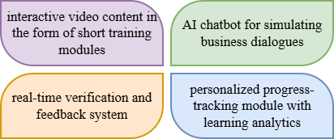

*Figure 1 - Main components of the developed web platform*

The main concept behind the development of the web platform. The developed system is an educational web platform accessible via a browser. The solution architecture includes a client part (frontend), a server part (backend) and an artificial intelligence module showed on Figure 2.

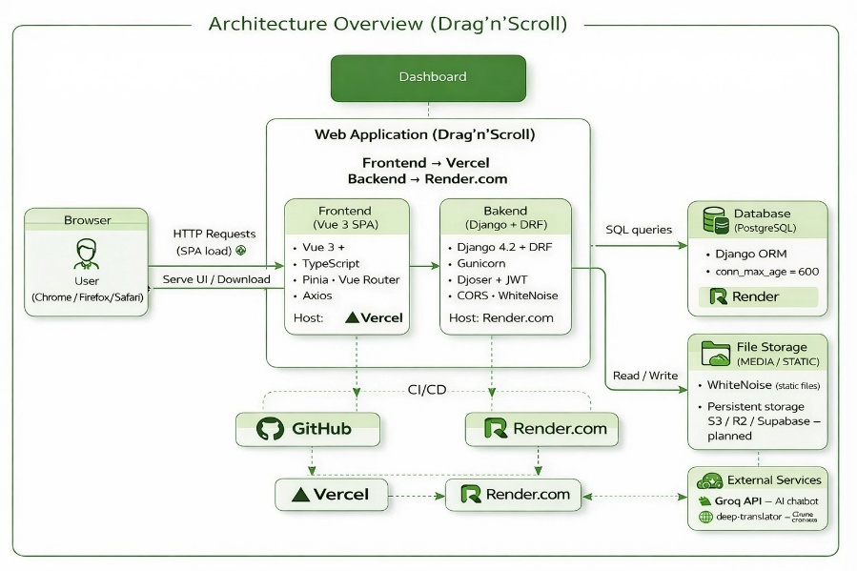

*Figure 2 - Architectural diagram of the Drag’n’Scroll web application*

PostgreSQL serves as the primary database system for storing user and application data. Interaction with the database is handled through Django ORM, which ensures structured query execution, data integrity and efficient connection management. The AI chatbot is integrated at the server level, where incoming user requests are processed and responses are generated using natural language processing techniques. Continuous integration and continuous deployment (CI/CD) practices, implemented via GitHub and cloud services, automate updates and system deployment. Overall, the selected architecture ensures scalability, operational stability and flexibility for future platform enhancements.

**Recommended mathematical model for evaluating platform effectiveness**

To enhance research objectivity, the use of quantitative metrics is proposed. The following formulas are recommended for future empirical analysis of the platform’s effectiveness. These indicators convert qualitative aspects of learning such as engagement, progress, and accuracy into measurable variables, supporting statistical analysis and adaptive personalization. The proposed formulas, shown in Tables 1 and 2, cover key aspects of the system's functioning: user progress assessment, knowledge gain, accuracy of interaction with the AI chatbot, personalized recommendation mechanism, probabilistic text generation model and system performance indicators. The proposed metrics enable a structured evaluation of the web platform’s effectiveness by translating qualitative learning outcomes into quantitative indicators. The Progress metric reflects the level of course completion, Learning Gain measures knowledge improvement after training modules, and Accuracy assesses the correctness of user responses in AI-driven dialogues, indicating the development of business communication skills.

Table 1 - Overview of mathematical models

|  |  |  |
| --- | --- | --- |
| **User progress assessment model** | **Learning effectiveness metric** | **Accuracy metric for responses in AI dialogues** |
| $$Progress=\frac{Completed Modules}{Total Modules}*100\%$$ | $$Learning Gain=\frac{{score}_{after}-{score}_{before}}{{score}_{before}}x100\%$$ | $$Accuracy=\frac{Correct Responses}{Total Responses}$$ |
| where: Completed Modules - number of completed modules, Total Modules - total number of modules, which shows the level of course completion. | where: Score_before is the result before completing the module, Score_after is the result after completing the module. This is already a comprehensive educational indicator | can be used to assess your command of business phrases |

Table 2 - Overview of mathematical models 1

|  |  |  |
| --- | --- | --- |
| **Personalization model (adaptability)** | **NLP logic of a chatbot (if you want to get technical)** | **System response time** |
| $$Recommendation Score=\sum{ω_{i}*x_{i}}$$ | $$P(w_{t}∣w_{1},w_{2},...,w_{t-1})$$ | $$Response Time=T_{server}-T_{request}$$ |
| If you have a recommendation system, where: $x_{i}$ user parameters (errors, topics, speed), $w_{i}$ weight of significance, which already looks like knowledge engineering | Text generation model: the probability of the next word given the previous ones, which shows that AI works on the basis of a probabilistic language model | can be added as a performance metric |

The comprehensive use of these indicators provides an objective assessment of the effectiveness of the educational process and creates a basis for the implementation of adaptive algorithms for personalizing learning. The learning concept is based on the principle of microlearning [5], which involves mastering material in small thematic blocks. Users learn business phrases through short videos, then reinforce their knowledge in a dialogue mode with an AI chatbot [6]. The platform includes the following main modules shown in Figure 3.

*Figure 3 - Main modules*

The interface was designed according to the principles of minimalism and functional expediency. The main characteristics of the interface shown in Figure 4.

Изображение выглядит как текст, снимок экрана, Шрифт, линия

Содержимое, созданное искусственным интеллектом, может быть неверным.

*Figure 4 - Interface characteristics*

Testing of the web platform, which was presented during the development process, identified functional and non-functional requirements in Table 3.

Table 3 - Functional and non-functional requirements

|  |  |  |
| --- | --- | --- |
| № | Functional requirements | Non-functional requirements |
| 1 | correct operation of the video module | usability |
| 2 | generation of relevant responses by the AI chatbot | system performance |
| 3 | recording of user progress | stability under high load |
| 4 | saving of session data | correct display on different devices |

During the testing phase, students were asked to complete the tasks illustrated in Figure 5. Their interactions with the platform were monitored and feedback was collected to evaluate usability and learning effectiveness. The summarized results of the testing process are presented in Figure 6.

|  |  |
| --- | --- |
|  |  |
| *Figure 5 - Testing tasks* | *Figure 6 - Test results* |

To validate the content, videos from the platform were published on TikTok, YouTube and Instagram [7]. Analysis of views and engagement showed growing interest in the microlearning format [8]. The results confirm that short videos effectively attract users and support initial learning before перехода to the web platform [9].

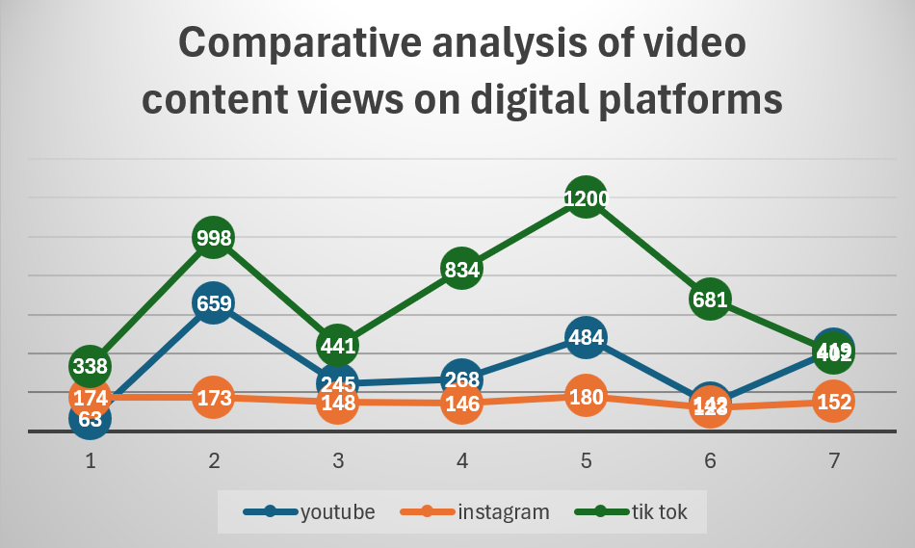

*Figure 7 - User engagement statistics and analysis of video content views on digital platforms*

As shown in Figure 7, the largest growth in views occurred within the first 72 hours after publication, confirming the effectiveness of algorithmic promotion for short educational content. TikTok demonstrated the highest and most consistent reach, indicating strong compatibility between microlearning formats and platform algorithms. YouTube showed moderate variability with occasional growth peaks, likely driven by recommendations, while Instagram maintained stable, but lower engagement. These results support the use of TikTok short videos as an effective tool for preliminary validation and promotion of the educational web platform.

**Conclusion**

As a result of the research, a web platform for studying business Chinese was developed and tested, integrating an AI chatbot and multimedia video content. An analysis of viewing statistics for educational materials on TikTok, YouTube, and Instagram confirmed the demand for short educational modules and demonstrated the highest audience reach on TikTok. The empirical data obtained indicates the high effectiveness of microlearning as a tool for attracting and engaging users. The use of artificial intelligence technologies enables the simulation of real business scenarios and the development of practical communication skills. The results of interface testing confirmed its compliance with usability, functionality, and stability requirements [10].

Further development of the project involves expanding the database of dialogue scenarios, introducing adaptive algorithms for personalizing training and scaling the platform to a wider audience of users, considering the analytical data obtained.

REFERENCES

1. Liu, W., Zhuang, G., Liu, X., Hu, S., He, R., & Wang, Y. (2021). How do we move towards true artificial intelligence. 2021 IEEE 23rd Int Conf on High Performance Computing & Communications; 7th Int Conf on Data Science & Systems; 19th Int Conf on Smart City; 7th Int Conf on Dependability in Sensor, Cloud & Big Data Systems & Application (HPCC/DSS/SmartCity/DependSys), 2156-2158.
2. Rosalin, K., Ying, Y., & Chandra, M.R. (2024). Chineseway Apps as Chinese Vocabulary Learning Tools. *2024 9th International Conference on Business and Industrial Research (ICBIR)*, 0548-0553.
3. Chandra, M.R., Luciana, A., Susilo, P.M., & Cindy (2024). The Use of Video-Based Learning to Improve Chinese Grammar Ability. *2024 9th International Conference on Business and Industrial Research (ICBIR)*, 1-4.
4. Zhao, K., & Lei, C. (2017). Technology-Enhanced Content and Language Integrated Learning in Chinese Tertiary English Classes: Potentials and Challenges.
5. Marti, N.W., Suharta, I.G., Agustini, K., Sudarma, I.K., Wijaya, I.N., & Ariani, L.P. (2024). DEVELOPMENT OF THE PROPOSED MICROLEARNING-BASED DYNAMIC INTELLECTUAL LEARNING SYSTEM TO ACTUALIZE AN EFFECTIVE LEARNING PROCESS IN ONLINE ENVIRONMENT. *Jurnal Pendidikan Teknologi dan Kejuruan*.
6. Winkler, R., & Söllner, M. (2018). Unleashing the Potential of Chatbots in Education: A State-Of-The-Art Analysis. *Academy of Management Proceedings*.
7. Abidin, C. (2020). Mapping Internet Celebrity on TikTok: Exploring Attention Economies and Visibility Labours. *Cultural Science Journal, 12*, 77 - 103.
8. Silva, E.S., Costa, W.P., Lima, J.C., & Ferreira, J.C. (2025). Contribution of Microlearning in Basic Education: A Systematic Review. *Education Sciences*.
9. Chen, G., & Yuan, Q. (2021). Application and existing problems of computer network technology in the field of artificial intelligence. *2021 2nd International Conference on Artificial Intelligence and Computer Engineering (ICAICE)*, 139-142.
10. Mayer, R.E. (2024). The Past, Present, and Future of the Cognitive Theory of Multimedia Learning. *Educational Psychology Review, 36*.

СПИСОК ЛИТЕРАТУРЫ

1. Liu, W., Zhuang, G., Liu, X., Hu, S., He, R., & Wang, Y. (2021). How do we move towards true artificial intelligence. 2021 IEEE 23rd Int Conf on High Performance Computing & Communications; 7th Int Conf on Data Science & Systems; 19th Int Conf on Smart City; 7th Int Conf on Dependability in Sensor, Cloud & Big Data Systems & Application (HPCC/DSS/SmartCity/DependSys), 2156-2158.
2. Rosalin, K., Ying, Y., & Chandra, M.R. (2024). Chineseway Apps as Chinese Vocabulary Learning Tools. *2024 9th International Conference on Business and Industrial Research (ICBIR)*, 0548-0553.
3. Chandra, M.R., Luciana, A., Susilo, P.M., & Cindy (2024). The Use of Video-Based Learning to Improve Chinese Grammar Ability. *2024 9th International Conference on Business and Industrial Research (ICBIR)*, 1-4.
4. Zhao, K., & Lei, C. (2017). Technology-Enhanced Content and Language Integrated Learning in Chinese Tertiary English Classes: Potentials and Challenges.
5. Marti, N.W., Suharta, I.G., Agustini, K., Sudarma, I.K., Wijaya, I.N., & Ariani, L.P. (2024). DEVELOPMENT OF THE PROPOSED MICROLEARNING-BASED DYNAMIC INTELLECTUAL LEARNING SYSTEM TO ACTUALIZE AN EFFECTIVE LEARNING PROCESS IN ONLINE ENVIRONMENT. *Jurnal Pendidikan Teknologi dan Kejuruan*.
6. Winkler, R., & Söllner, M. (2018). Unleashing the Potential of Chatbots in Education: A State-Of-The-Art Analysis. *Academy of Management Proceedings*.
7. Abidin, C. (2020). Mapping Internet Celebrity on TikTok: Exploring Attention Economies and Visibility Labours. *Cultural Science Journal, 12*, 77 - 103.
8. Silva, E.S., Costa, W.P., Lima, J.C., & Ferreira, J.C. (2025). Contribution of Microlearning in Basic Education: A Systematic Review. *Education Sciences*.
9. Chen, G., & Yuan, Q. (2021). Application and existing problems of computer network technology in the field of artificial intelligence. *2021 2nd International Conference on Artificial Intelligence and Computer Engineering (ICAICE)*, 139-142.
10. Mayer, R.E. (2024). The Past, Present, and Future of the Cognitive Theory of Multimedia Learning. *Educational Psychology Review, 36*.

**Бахитбеков А. Ж., Сағынбай А. Е., Бахитбеков А. Ж.**

**Ғылыми жетекшісі: Бакирова Г.С.**

**Чатбот интеграциясымен жасанды интеллект технологиялары негізінде бизнес-қытай тілін оқытуға арналған интеллектуалды веб-платформаны әзірлеу AI-бот және мультимедиалық бейнеконтенті бар**

**Аңдатпа**. Мақалада жасанды интеллект технологиялары мен интерактивті бейнеконтентті пайдалана отырып, іскерлік қытай тілін үйренуге арналған веб-платформаны әзірлеу тұжырымдамасы ұсынылған. Ол Қытаймен қатынастарда халықаралық сауда ортасында практикалық іскерлік коммуникация дағдыларын дамытуға бағытталған цифрлық білім беру шешімін жасаудың алғышарттарын қарастырады. Платформаның клиенттік және серверлік бөліктерін, сондай-ақ табиғи тілді өңдеу модулін қоса алғанда, архитектурасы егжей-тегжейлі сипатталған. Пайдаланушы интерфейсін ыңғайлы әрі интуитивті өзара әрекеттесуді қамтамасыз етуге бағытталған дизайн қағидалары айқындалған. Функционалдық және функционалдық емес талаптарды сынау нәтижелері ұсынылған. Нақты келіссөз сценарийлерін модельдеу және автоматтандырылған кері байланыс құралы ретінде жасанды интеллект чат-ботын интеграциялауға ерекше назар аударылған.

**Түйінді сөздер**: веб-платформа, жасанды интеллект, AI чат-бот, іскерлік қытай тілі, интерактивті оқыту, білім берудегі цифрлық технологиялар.

**Бахитбеков А. Ж., Сагынбай А. Е., Бахитбеков А. Ж.**

**Научный руководитель: Бакирова Г.С.**

**Разработка интеллектуальной веб-платформы для обучения деловому китайскому языку на основе технологий искусственного интеллекта с интеграцией чат-бота с ИИ и мультимедийного видеоконтента**

**Аннотация**. В статье представлена концепция разработки веб-платформы для изучения делового китайского языка с использованием технологий искусственного интеллекта и интерактивного видеоконтента. Рассмотрены предпосылки для создания цифрового образовательного решения, ориентированного на развитие практических навыков делового общения в сфере международной торговли в отношениях с Китаем. Подробно описана архитектура платформы, включая клиентскую и серверную части, а также модуль обработки естественного языка. Выделены принципы проектирования пользовательского интерфейса, направленные на обеспечение удобства и интуитивного взаимодействия. Представлены результаты тестирования функциональных и нефункциональных требований. Особое внимание уделено интеграции чат-бота на базе искусственного интеллекта как инструмента для моделирования реальных сценариев переговоров и автоматической обратной связи.

**Ключевые слова**: веб-платформа, искусственный интеллект, чат-бот на базе искусственного интеллекта, деловой китайский язык, интерактивное обучение, цифровые технологии в образовании.

**Сведения об авторах:**

**Бахитбеков Айбатыр Жандосович**, студент Международного университета информационных технологий

**Сагынбай Ару Ерболаткызы**, студентка Назарбаев Университета

**Болатов Жігер Жасұланұлы**, студент Назарбаевской интеллектуальной школы

**About the authors:**

**Bakhitbekov Aibatyr Zhandosovich**, student at International Information Technology University

**Sagynbay Aru Yerbolatkyzy**, student at Nazarbayev University

**Bakhitbekov Arsen Zhandosovich**, student at Nazarbayev Intellectual School

**Авторлар туралы ақпарат:**

**Бахитбеков Айбатыр Жандосович**, Халықаралық ақпараттық технологиялар университетінің студенті

**Сағынбай Ару Ерболатқызы**, Назарбаев университетінің студенті

**Бахитбеков Арсен Жандосович**, Назарбаев зияткерлік мектебінің студенті